NJ Schools Week of Respect:
Monday October 7th -Friday October 11^{h} 2024
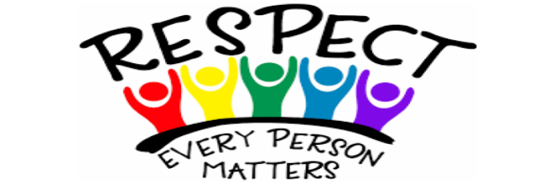

Hello Bullock Families,

Each year during the first week of October we celebrate the NJ Week of Respect in honor of National Bullying Prevention Month. This year the Bullock School will celebrate with a week of spirit days. Additionally, we will be reading the text “The Juicebox Bully”, taking a pledge against bullying, and other classroom activities. Visit our school counseling webpage for more information. Our spirit days this year are as followed:

Monday Oct. 7th: Blue Up for World Bullying Prevention Month-Wear lots of blue

Tuesday Oct 8th: Team up against bullying-Wear your favorite team jersey or sports wear

Wednesday Oct. 9th: Don’t sweat the small stuff -Wear sweats or workout clothes

Thursday Oct. 10th: We have Bulldog PRIDE at Bullock School -Wear maroon and gold or Glassboro spirit wear

Friday Oct. 11th:(Teacher Inservice day-students off): Relax, Respect, and Repeat-Wear your PJs all day

*Upcoming event on Oct 16th (*Unity Day)-Wear orange
*Upcoming event on Oct 18th (*Breast Cancer Awareness)-Wear pink

Ms. Evans & Ms. Belcher
Bullock School Counselors

